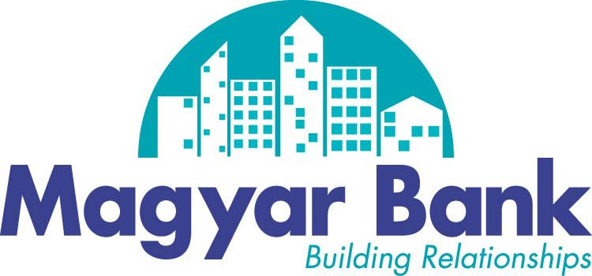

Thank you for choosing Magyar Bank. We understand that you have many choices when it comes to finding a financial services provider, and we are pleased that you have chosen Magyar Bank.
We have made transferring your checking account to Magyar Bank easy—just follow the steps outlined below and complete the appropriate forms to start enjoying the benefits of being a Magyar Bank customer.

- If you have not already done so, open a Magyar Bank checking account.

- Complete application for Business Online Banking and Bill Pay with your new checking account
- Open a Magyar Business Debit Card—your Card is issued with your Magyar Bank checking account.
- Change all of your automatic payments and funds transfers to your new Magyar checking account by using the letter we have provided.
- Close your former account, but be sure that all checks you may have written have been cashed and all automatic payments have been stopped.

That is how easy it is for you to start discovering the “Magyar Experience” for yourself. Of course, if at anytime you have any questions, stop by the branch nearest you or call 1.888.990.BANK.

Member FDIC

Automatic Payment Authorization Letter

Date:

To:

Re: Change in account for automatic payments

Please accept this letter as authorization to change the account information for my automatic payment. Effective immediately, please have this payment made directly from the following account:

Magyar Bank Account Number: Magyar Bank ABA Number: 221270910

If you have any questions or need additional information, please contact Magyar Bank at 1.888.990.BANK.

Thank you for your assistance.

Account Holder Signature Date

Account Holder Signature Date

